.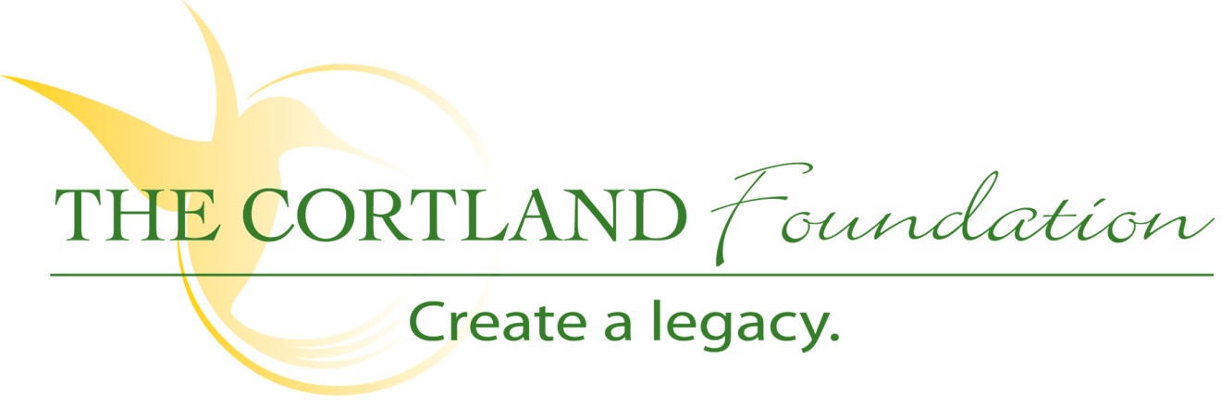

FOR IMMEDIATE RELEASE
Contact: Cary Sponaugle, PR and Marketing Specialist
(304) 463-4181; cary@cortlandacres.org

Tucker County Photography Club sponsoring public tour of photography exhibit

Thomas, WV – Members of the Tucker County Photography Club invite the public to tour the Cortland Acres Photography Exhibition this Saturday, from 1 pm to 3 pm, as part of the 2018 ArtSpring festivities. This juried collection of Tucker County nature photography is the result of an annual photo contest and fundraising event for The Cortland Foundation. Cortlands’ “Bringing the Outside In” photo contest and exhibition concept recently won the West Virginia Health Care Associations Best Practice award.
The contest invites photographers to submit up to four high resolution images for consideration. Subjects should highlight the beauty and activities found in the northern West Virginia and western Maryland areas - representing of people, places and pursuits found in this region.
A total of fourteen 40 inch by 60 inch high definition canvas prints are on display throughout Cortland Acres. There is additional 16 inch by 24 inch high definition canvas prints also on display on various wings of the facility.
Photographers interested in submitting images should go to http://blackwater.cortlandacres.org, complete the submission form and upload as many as four images. Submissions will be accepted until June 30, 2018. Photographers of selected images will be notified by July 31, 2018. Unveiling of the exhibition will occur in September, the exact date and time to be announced in August. Questions may be directed to David Miller at frostline.wv@gmail.com.
The Foundation, a 501(c)3 organization, is dedicated to helping Cortland Acres continue to provide and expand quality care and services to the local and surrounding communities. Cortland Acres is a non-profit corporation offering state-of-the-art nursing care and skilled rehabilitation on a spacious 35-acre campus is the heart of scenic Tucker County, West Virginia. The Cortland campus includes a 94-bed long-term care facility, inpatient and outpatient rehabilitation and therapy options, as well as a variety of independent living opportunities. For more information call 304-463-4181 or visit www.cortlandacres.org.

“To secure the resources necessary to enhance the health and well-being of the Cortland community”
# # #

Photo: Cortland Acres administrator Beth Clevenger and resident Vincent DiBacco admire “Flatrock Run Upper Falls” by photographer Brian Peterman – one of the many photo submissions displayed throughout Cortland Acres as part of their Bringing the Outside In program.

