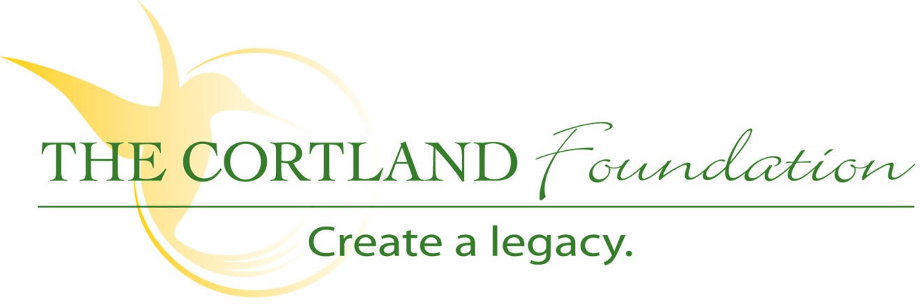

FOR IMMEDIATE RELEASE
Contact: Cary Sponaugle, PR and Marketing Specialist
(304) 463-4181; cary@cortlandacres.org

The Cortland Foundation Unveils New Photography Exhibit

Thomas, WV – The Cortland Foundation hosted the second annual photography and wood craft auction on September 27th. The highlight of the evening was the unveiling of fourteen new photographic prints for the Blackwater Short-term Rehab wing. An additional, ten smaller images were unveiled and will be displayed throughout the facility.
The Cortland Foundation partnered with the Tucker County Photography Club to encourage photographers from around West Virginia and beyond submitted images that highlight the beauty and activities found in the northern West Virginia and western Maryland area and are representative of the people, places and pursuits found in this region. In the end, a total of one hundred and nine images were judged and curated by award-winning photographer Wil Hershberger.
In addition to auctioning photographs from last years’ collection, a variety of wood craft items from local wood artisans Travis Hamrick, Mark Warner, Tom DiBacco and Jared Parsons were also auctioned.
“Cortland Acres is honored to serve the community and the many people who choose our services,” explains Cortland Administrator Beth Clevenger. “Events like the photography unveiling and auction bring people onto our campus to see first-hand the five-star service we’re known for across the area. Skilled nursing care has definitely changed over the years and Cortland is listening to the community’s expectations by providing options such as independent living at The Pines, short-term rehab in our Blackwater unit and more. Cortland celebrates 40 years of service this year and I think the best is yet to come. The future of elder care is constantly evolving and we’re committed to leading the way with innovative solutions.”
The Foundations’ mission is “To secure the resources necessary to enhance the health and well-being of the Cortland community”. A 501(c)3 organization, The Foundation is dedicated to helping Cortland Acres continue to provide and expand quality care and services to the local and surrounding communities. Cortland Acres is a non-profit corporation offering state-of-the-art nursing care, skilled rehabilitation and retirement living on a spacious 35-acre campus in the heart of scenic Tucker County, West Virginia. For more information call 304-463-4181 or visit www.cortlandacres.org.

# # #

Auction Photo 1: (Left to Right) Director of Development at Cortland Acres, Dan Bucher looks on as photographer Joseph Henry describes his winning entry “Laurel Buds at Allegheny Front 2” to onlookers and contest judge Wil Hershberger.
Auction Photo 2: Ten stunning photographs were also selected for smaller canvases and proudly displayed for up-close inspection by auction-goers. All ten will be installed throughout the Cortland Acres facility.

Auction Photo 3: (Left to Right) Dan Bucher watches as auctioneer and Cortland Board President Pat Nichols describes “Two Paths Diverge” by photographer David J. Miller and held by David Cooper.

Auction Photo 4: (Left to Right) Pat Nichols fields bids and David Cooper holds a cutting board made by local craftsman Tom DiBacco. Other wood items can be seen in the background waiting for auction.

