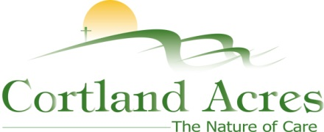
FOR IMMEDIATE RELEASE
Contact: Cary Sponaugle, PR and Marketing Specialist
(304) 463-4181; cary@cortlandacres.org

Cortland Acres recognizes years of service on National Thank You Day
Thomas, WV – Cortland Acres celebrated their annual Years of Service awards on National Thank You Day at The Bright Morning Inn in Davis last Friday. A total of twelve staff members were honored for years of service ranging from five to forty years. The annual event is a chance to thank staff for their dedication and the part they play to enrich the lives of Cortland residents.
“We wouldn’t be an award-winning facility without the dedication and hard work of our staff”, explains administrator Beth Clevenger. When choosing a date for the awards, it just made sense to hold it on National Thank You Day. Managers introduced each recipient from their respective departments and told their amazing stories of dedication. I realize how lucky we are to have staff members that are part of the Cortland family, and it’s not just a job.”
Bonnie Putlovis, Rose Buck and Judy Stone were each honored for five years of service and Ashley Neville was honored for ten years of service. Fifteen-year service honors went to Angie Bland and Donna Hedrick while twenty-five year honorees included Jerry Marsh, Loretta Phillips and Dee Simmons. Denise Leary and Kathy Supak received recognition for thirty years of service and Ellen Paugh was honored for an amazing forty-years of service.
“Cortland does so much for us throughout the year,” explains Health Information Management / clerical staff member Donna Hedrick. “It’s wonderful to be appreciated. Everyone here is my work family and I enjoy my work.” Ellen Paugh sums it up this way, “I enjoy my days at Cortland and have seen it grow and evolve over the years. What started off as a convenient local job forty years ago has turned into a meaningful career.”

The Cortland campus includes a 94-bed long-term care facility, inpatient and outpatient rehabilitation and therapy options, as well as a variety of independent living opportunities. For more information call 304-463-4181 or visit www.cortlandacres.org.
Helping people age in healthy, affordable, and meaningful ways.
# # #

Photo 1:

