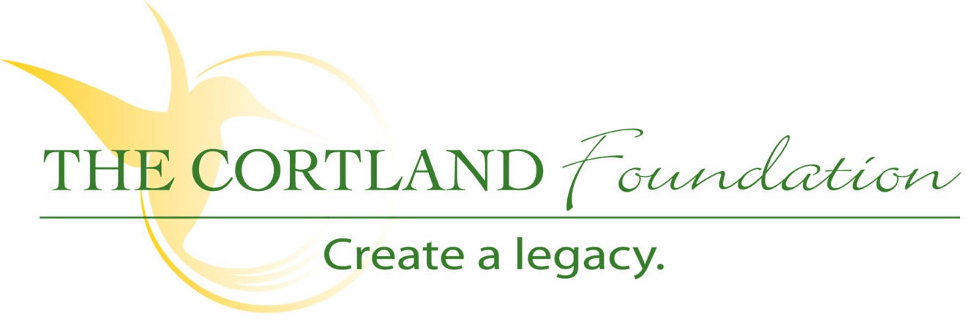

FOR IMMEDIATE RELEASE
Contact: Cary Sponaugle, PR and Marketing Specialist
(304) 463-4181; cary@cortlandacres.org

The annual Pasta Palooza benefits the TCHS ProStart Program

Thomas, WV – The 7th annual Pasta Palooza will be held at Cortland Acres on Thursday, May 9th and benefits both the Tucker County High School ProStart Program and The Cortland Foundation.
Each plate is individually prepared by TCHS ProStart students and their program instructor, Chef Carrie Shahan. During the event itself, Shahan and her student staff cook an assortment of pasta, prepare a variety different sauces and a mountain of garlic bread. At least six students take care of preparing the various pasta items while two students are devoted to re-filling trays. The Pasta Palooza event allows the students a chance to show the community the skills they have learned while in the ProStart program. In the past, students that have worked this event have even gotten job offers from businesses who have attended.
“This is an important event for our program,” explains TCHS ProStart director Shahan. “My students and I look forward to the Pasta Palooza each year. They ask me at the beginning of every school year when it is and they sign up to work it months in advance to make sure they get to help. This event also gives the students a chance to see how to cater large events and how much work goes into something like this to make it a success.”

Sponsored by the National Restaurant Association Educational Foundation, ProStart is a nationwide, two-year high school program that gives students a chance to discover new interests and talents that can lead to fulfilling careers. ProStart’s industry-driven curriculum teaches culinary techniques and management skills, while also providing real-life experience opportunities that build practical skills.
The Pasta Palooza menu includes a variety of pasta and sauce options with a diverse selection of fresh ingredients to be added at your request such as crushed garlic, fresh spinach, meatballs, grilled chicken, sweet Italian sausage and much more. The menu also includes Caesar salad, garlic bread, freshly brewed ice tea or fresh squeezed lemonade and dessert.
Tickets to the Pasta Palooza are $15 per person or $20 at the door and benefits the Tucker County High School ProStart program and The Cortland Foundation. You may purchase tickets in advance from any ProStart student, at Cortland Acres by calling 304-463-4181 or emailing lnelson@cortlandacres.org.
The Cortland Foundation, a 501(c)3 organization, helps to provide and expand quality care and services to Tucker County and beyond during a time when the cost of providing that care continues to increase. The Foundation recognizes that so much more can be accomplished thru the impact of philanthropic gifts. If you’d like to find out how you can help, please call Dan Bucher at 304-463-4181 or visit www.cortlandacres.org.
“To secure the resources necessary to enhance the health and well-being of the Cortland community”
# # #

