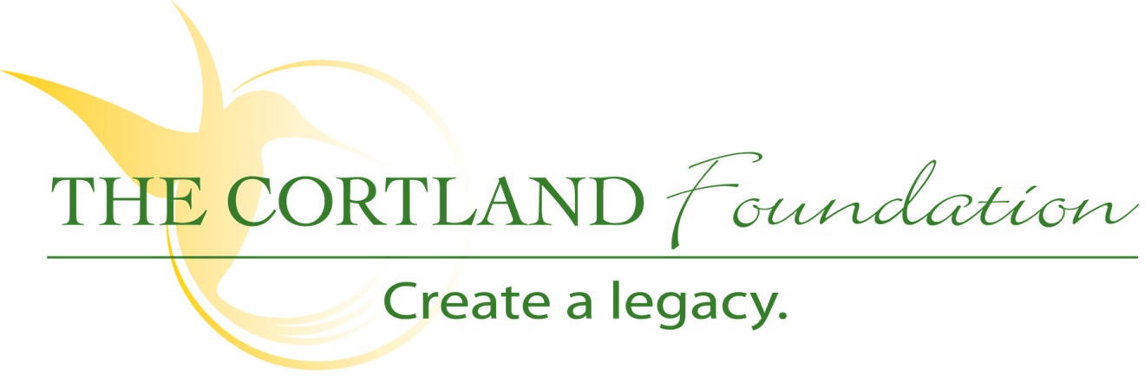

FOR IMMEDIATE RELEASE
Contact: Cary Sponaugle, PR and Marketing Specialist
(304) 463-4181; cary@cortlandacres.org

This years’ Pasta Palooza is best ever

Thomas, WV – The 7th annual Pasta Palooza was held at Cortland Acres on Thursday, May 9th, with proceeds benefiting both the Tucker County High School ProStart Program and The Cortland Foundation.
The aroma of fresh spices and sautéing vegetables guided visitors to The Cortland Cafe where patrons enjoyed a freshly prepared Italian bistro-style menu. Festive decorations and beautiful floral arrangements donated by ThomasYard set the mood for an enjoyable dining event to raise funds for two local organizations.
Seven year patrons Kathy and Pat Kotten remarked, “We look forward to the Pasta Palooza every year. It’s always very enjoyable and the food is delicious”.
Six members of TCHS ProStart and program Director and Chef Carrie Shahan cooked non-stop for members of the local community, Cortland residents and their families. Aurora Bunnell, Laurel Inglese, Calista Eye, Madison Johnson, Lauren McCrum, Kearsten Adkins and other members of this semester’s ProStart program began preparing for this annual fundraiser weeks ago. The day of the Pasta Palooza started early for everyone and cumulated with 17 hours of food prep, cooking and serving an estimated one hundred of guests.
“Each student must participate in at least one catering event per semester,” explains Chef Shahan. “The Pasta Palooza is one of our biggest. We typically go through sixty to seventy pounds of assorted pasta, ten gallons of sauce and hours of slicing and dicing various ingredients before we step in front of a skillet. All forty students helped with preparations, but it just so happened that this cooking crew was all girls – it was a fun evening.”
Tickets to the events were sold by Cortland Acres and TCHS ProStart students in advance and also available at the door. Patrons could elect to dine in or carry out their meals. This popular annual event is just one way The Cortland Foundation works to secure resources to help Cortland Acres provide and expand quality care and services to the Tucker County Community and surrounding area.
Now in its eighth year, the Foundation and its board members actively engage the local community with fundraising events like this one throughout the year.
The Foundation, a 501(c)3 organization, is dedicated to helping Cortland Acres continue to provide and expand quality care and services to the local and surrounding communities. Cortland Acres is a non-profit corporation offering state-of-the-art nursing care and skilled rehabilitation on a spacious 35-acre campus is the heart of scenic Tucker County, West Virginia. The Cortland campus includes a 94-bed long-term care facility, inpatient and outpatient rehabilitation and therapy options, as well as a variety of independent living opportunities. For more information call 304-463-4181 or visit www.cortlandacres.org.

“To secure the resources necessary to enhance the health and well-being of the Cortland community”
# # #

Photo 1: TCHS ProStart - - (left to right) Aurora Bunnell, Laurel Inglese, Calista Eye, Chef Carrie Shahan, Madison Johnson, Lauren McCrum, and Kearsten Adkins.
Photo 2: Kathy and Pat Kotten toast another delightful Pasta Palooza at Cortland Acres.
Photo 3: Cortland residents enjoy the 7th Annual Pasta Palooza

