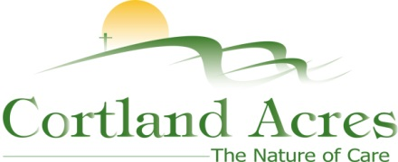

FOR IMMEDIATE RELEASE
Contact: Cary Sponaugle, PR and Marketing Specialist
(304) 463-4181; cary@cortlandacres.org

Summer Certified Nursing Assistant course starting soon at Cortland Acres

Thomas, WV – Cortland Acres will be offering a free Certified Nursing Assistant (CNA) course Monday through Friday starting June 4th through July 12th. Students will participate in a series of classroom lectures and focus on the application of acquired skills to assist residents with their basic needs. Open to anyone interested in getting into the healthcare field, the course allows students to utilize Cortland Acres’ vast facilities for hands-on training and classroom instruction to earn their CNA certification.
“This course may be your first step to a dream career,” explains Cortlands’ CNA program director Kathy Supak. “Cortlands CNA students never fail to impress me with their level of dedication and sense of responsibility. Their ability and insight can have enormous impact on helping patients make it through recovery or come to terms with a long-term condition.”
All students will be provided uniforms, textbooks, and medical equipment to use during class, students receive a travel stipend and even payment to take the certification exam. Currently, there are several openings available for the course starting in June, but space is limited.
Upon completion of the course and certification, applications for employment at Cortland Acres may be offered. These are opportunities for full- or part-time positions with benefits. For more information call Lois Nelson at 304-463-4181 or email lnelson@cortlandacres.org.
Cortland Acres is a non-profit corporation offering state-of-the-art nursing care and skilled rehabilitation on a spacious 35-acre campus is the heart of scenic Tucker County, West Virginia. The Cortland campus includes a 94-bed long-term care facility, inpatient and outpatient rehabilitation and therapy options, as well as a variety of independent living opportunities. For more information call 304-463-4181 or visit www.cortlandacres.org.

Helping people age in healthy, affordable, and meaningful ways.
# # #

