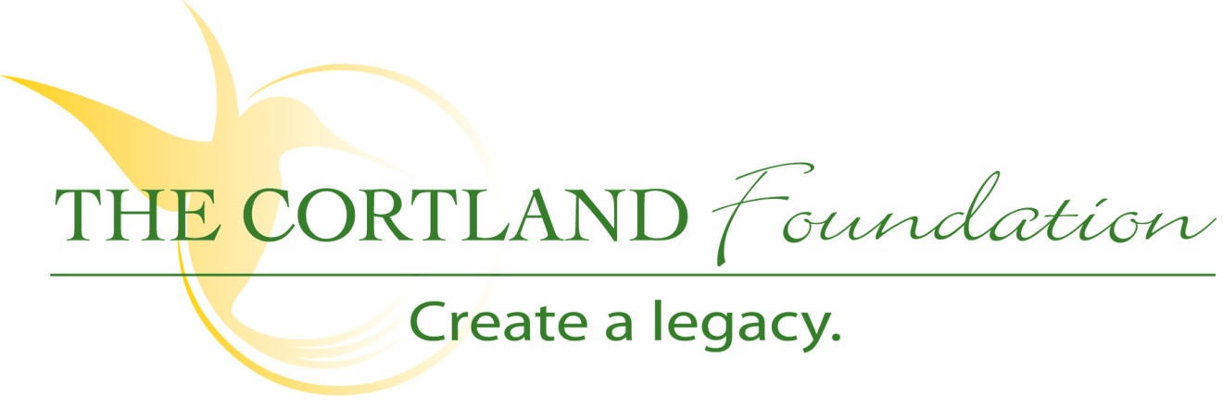
FOR IMMEDIATE RELEASE
Contact: Cary Sponaugle, PR and Marketing Specialist
(304) 463-4181; cary@cortlandacres.org

The Cortland Foundation Receives Electric Car

Thomas, WV – The Cortland Foundation recently purchased an electric vehicle branded “Bubble Buddy”. Made possible by proceeds from fundraisers and unrestricted gifts from generous donors, the unique four-passenger vehicle has a wide-range of practical applications for Cortland’s thirty-five acre retirement community.
“The Foundation’s ongoing mission is to enhance the health and well-being of the Cortland community,” explains Administrator, Beth Clevenger. “The Bubble Buddy will enable us to transport residents; deliver meals from the Cortland restaurant to the retirement homes and apartments; and even an occasional Sunday drive around campus. I also envision using the Bubble Buddy to show our campus to families and individuals considering Cortland Acres as their next residence. The possibilities are endless.”
Not to be confused with the Bubble Buddy character on the popular children’s cartoon SpongeBob, Cortland’s’ street legal Bubble Buddy can accommodate up to four passengers comfortably, boasts a top speed of 25 mph and is made in the USA. Standard features of the automatic EV include an AS1 safety glass windshield with wiper, twelve inch aluminum rims, three mirrors, headlights, turn signals, rear brake lights and blinkers, backup beeper, horn, locking trunk and stereo with CD player.
“Since its arrival, the electric Bubble Buddy has certainly attracted a lot of attention on campus,” states Dan Bucher, development director for The Cortland Foundation . “This vehicle represents the far reaching impact that donors have on residents in the Cortland community.”

The Foundation, a 501(c)3 organization, is dedicated to helping Cortland Acres continue to provide and expand quality care and services to the local and surrounding communities. Cortland Acres is a non-profit corporation offering state-of-the-art nursing care and skilled rehabilitation on a spacious 35-acre campus is the heart of scenic Tucker County, West Virginia. The Cortland campus includes a 94-bed long-term care facility, inpatient and outpatient rehabilitation and therapy options, as well as a variety of independent living opportunities. For more information call 304-463-4181 or visit www.cortlandacres.org.

“To secure the resources necessary to enhance the health and well-being of the Cortland community”
# # #
PHOTO: Seated in the Bubble Buddy are Cortland resident Martha Wolfe and Cortland Foundation development director Dan Bucher. Seated in the back is Cortland nursing assistant Raeanna Martin.

