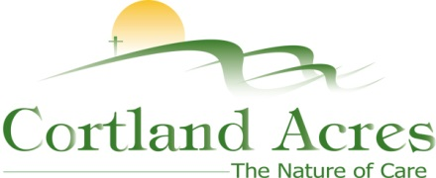
FOR IMMEDIATE RELEASE
Contact: Cary Sponaugle, PR and Marketing Specialist
(304) 463-4181; cary@cortlandacres.org

Cortland Acres’ Blackwater Rehab celebrates success
Thomas, WV – The Blackwater Short-term Rehab Center, an extension of Cortland Acres, held a Going Home Party to celebrate the successful completion of rehabilitation of four residents. Following weeks of hard work to overcome physical obstacles, each resident completed individual treatment plans to return home and resume their normal life.
“We couldn’t be more proud”, explains physical therapist Brooke Mangold, PT, DPT. “Each of these residents pushed themselves through physical and sometimes even emotional challenges to achieve their individual goals. It’s so easy to just give up in the face of pain, but they didn’t give up on themselves. We were there for every step and every milestone to make sure they returned home to pick up where they left off.”
“I’ve loved my stay here at Blackwater”, explains Phyllis Armentrout. “Not having to cook or clean has really helped me concentrate on getting better, faster.” Donna Wolfe credits Blackwater Short-term Rehab Center for getting her back on her feet. “I really didn’t think I’d ever walk again. Thanks to my talented surgeon and the physical therapists here at Cortland, I’m actually better and stronger than before. I even lost forty pounds too! I would definitely recommend Blackwater Rehab to anyone needing physical therapy.”

The Cortland campus includes a 94-bed long-term care facility, inpatient and outpatient rehabilitation and therapy options, as well as a variety of independent living opportunities. For more information call 304-463-4181 or visit www.cortlandacres.org.
Helping people age in healthy, affordable, and meaningful ways.
# # #

Photo 1: (left to right, seated) – New friends Donna Wolfe and Martha Wolfe celebrate at the recent “Going Home Party” at Cortland’s Blackwater Short-term Rehab Center.

