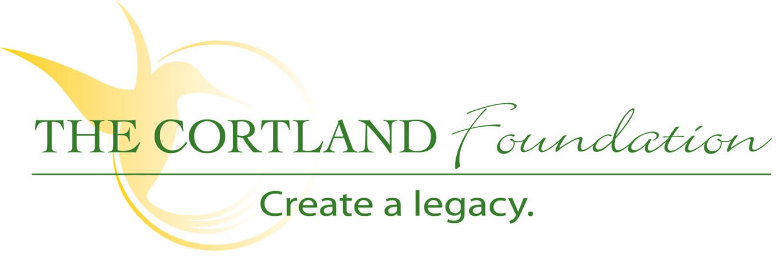

FOR IMMEDIATE RELEASE
Contact: Cary Sponaugle, Director PR and Marketing
(304) 463-4181; cary@cortlandacres.org

Tucker High School ProStart and the Cortland Foundation
announce details for the 7th Annual Pasta Palooza

Thomas, WV - - The 7th annual Pasta Palooza will be held at Cortland Acres on Thursday, May 9th from 5:30 to 7:30 pm. Net proceeds benefit the Tucker County High School ProStart Program and The Cortland Foundation. This year, tickets are required for admission and sell for $15 per person from any TCHS ProStart student and at Cortland Acres in advance of the event and $20 at the door.
As with past Pasta Palooza events, each meal is made-to-order by TCHS ProStart students and their program instructor, Carrie Shahan. As the name suggests, the event will include a wide variety of pasta and sauce options and a diverse selection of fresh ingredients to be added such as crushed garlic, fresh spinach, an assortment of grated cheese, meatballs, grilled chicken, sweet Italian sausage and much more. The menu also includes Caesar salad, garlic bread, freshly brewed ice tea or fresh squeezed lemonade and dessert.
This popular annual event is just one way The Cortland Foundation works to secure resources and provide quality care and services to the Tucker County community and surrounding area. Now in its eighth year, the Foundation and its board work to actively engage the local community and to educate them on all the exciting Vision 2030 initiatives underway.
“The annual Pasta Palooza never disappoints”, explains Cortland’s Director of Development Dan Bucher. “Great food, excellent service, and wonderful conversation make for an evening to be remembered. The ProStart students and their advisor Carrie Shahan, do a fantastic job every year with delightful pasta creations and the freshest ingredients. This is one of those annual events that keep growing by leaps and bounds every year and people look forward to attending. This year we’ve added advance ticket sales to help us better manage our overhead and make sure we have enough ingredients to meet the growing demand. Tickets are just $15 per person in advance and $20 at the door.”
As always, your generous support benefits the Tucker County High School ProStart program and The Cortland Foundation. Cortland Acres’ residents will be served prior to the start of the event and family members are encouraged to join them. Reservations are required whether you dine with a resident or during the event and may be made by calling 304-463-4181 or emailing lnelson@cortlandacres.org.
The Cortland Foundation, a 501(c)3 organization, helps to provide and expand quality care and services to Tucker County and beyond during a time when the cost of providing that care continues to increase. The Foundation recognizes that so much more can be accomplished thru the impact of philanthropic gifts. If you’d like to find out how you can help, please call Dan Bucher at 304-463-4181 or visit www.cortlandacres.org.

“To secure the resources necessary to enhance the health and well-being of the Cortland community”
# # #
Photo: Pasta Palooza flyer

